Swapping Charging Station report by
Electronics Team

- Revision Number:
Rev. 1.0
- Date of Creation or Update:
25/1/2025
- Prepared By:
Muhammad Sabahat Akhter
Muhammad Suleman

Reviewed By:

Mr. Humayun

Mr. Kamran

1.Circuit Breaker Connectivity Issue
Initially, a 32A circuit breaker was installed as the main breaker for the charging station. However, during operation, it was observed that the breaker frequently tripped, indicating insufficient capacity to handle the current load.

Actions Taken:
- The 32A circuit breaker was replaced with a 63A main breaker to ensure adequate current handling capacity.
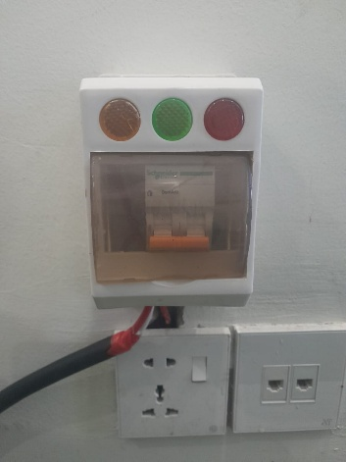
- A 63A safety double breaker was also installed with proper wiring to enhance the protection of the system against overloads and short circuits.
Figure1 : Safety breaker installed
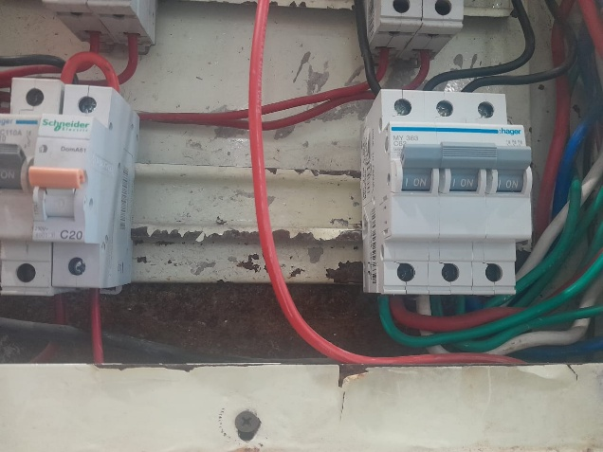
Figure2: Right hand circuit breaker replaced with 63 amp

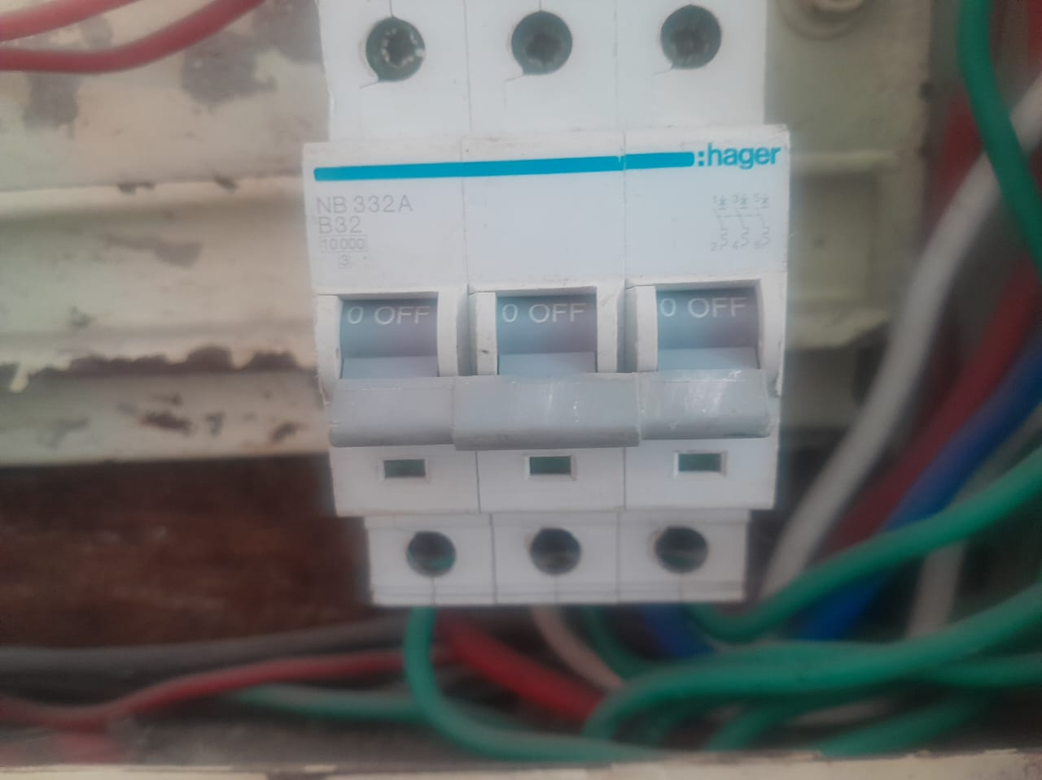
Figure 3: Old circuit breaker 32 amp

2. Testing of Chargers
The charging station consists of 12 chargers. The following observations were made during the installation and testing process:

Working Chargers:
- All 12 chargers were found to be functioning correctly and charging the batteries as expected.
- Cross-verification of parameters on the server console confirmed accurate readings for 11 chargers.

3. Charger and Slot Anomalies
- Charger Behavior During Testing:
  - During testing with the 32A breaker, one charger stopped working after a spark occurred. This may have been caused by the insufficient capacity of the 32A breaker under load, which has since been resolved by upgrading to a 63A breaker. The affected charger is replaced in charging station and needs to be inspected by Engineer Suleman.
- Slot 6:
  - The door functionality is working properly, indicating that the slave circuit for this slot is operational.
  - However, the parameters for this slot are not appearing on the dashboard. This suggests a possible server-side issue.
- Other Slots:
  - Some values are correctly showing on the console but are not displayed on the dashboard. This discrepancy is also likely due to server-side issues.

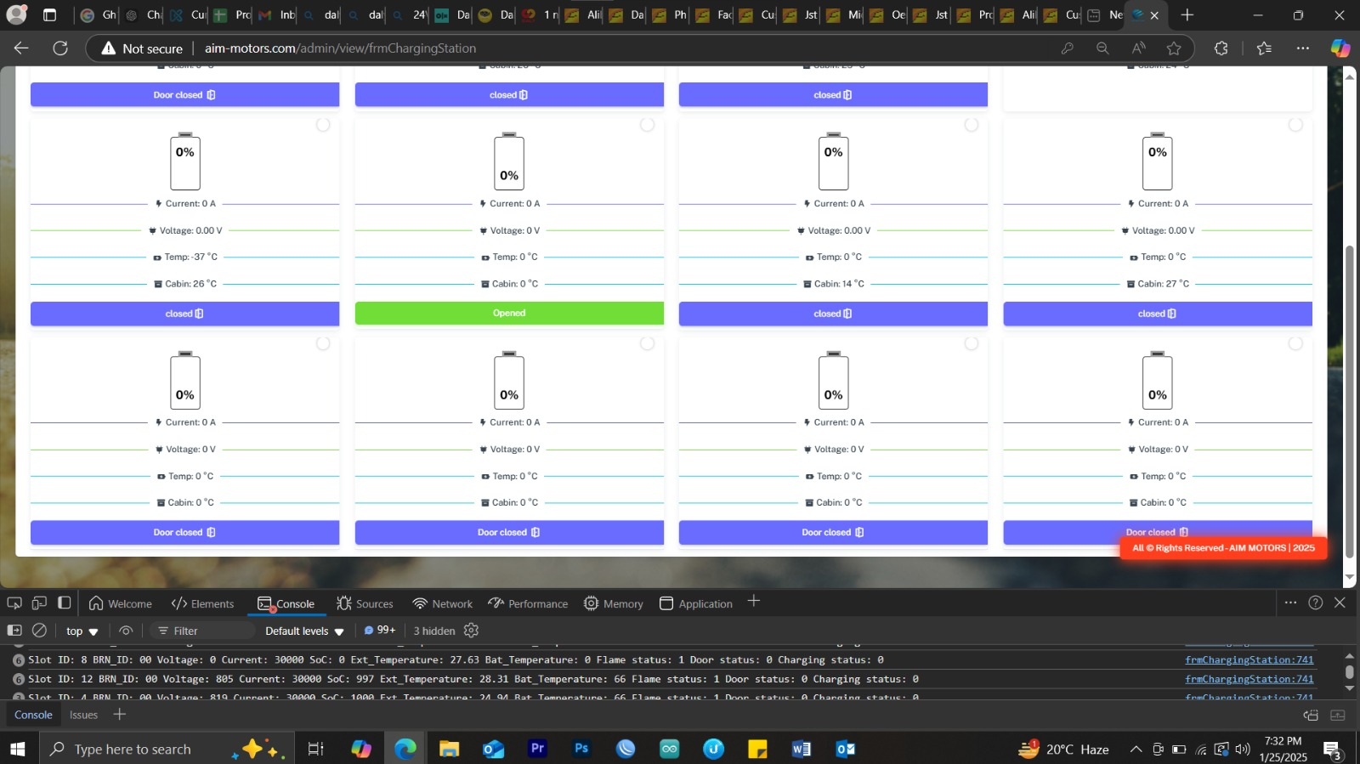
Slot 12 showing on console but not on dashboard

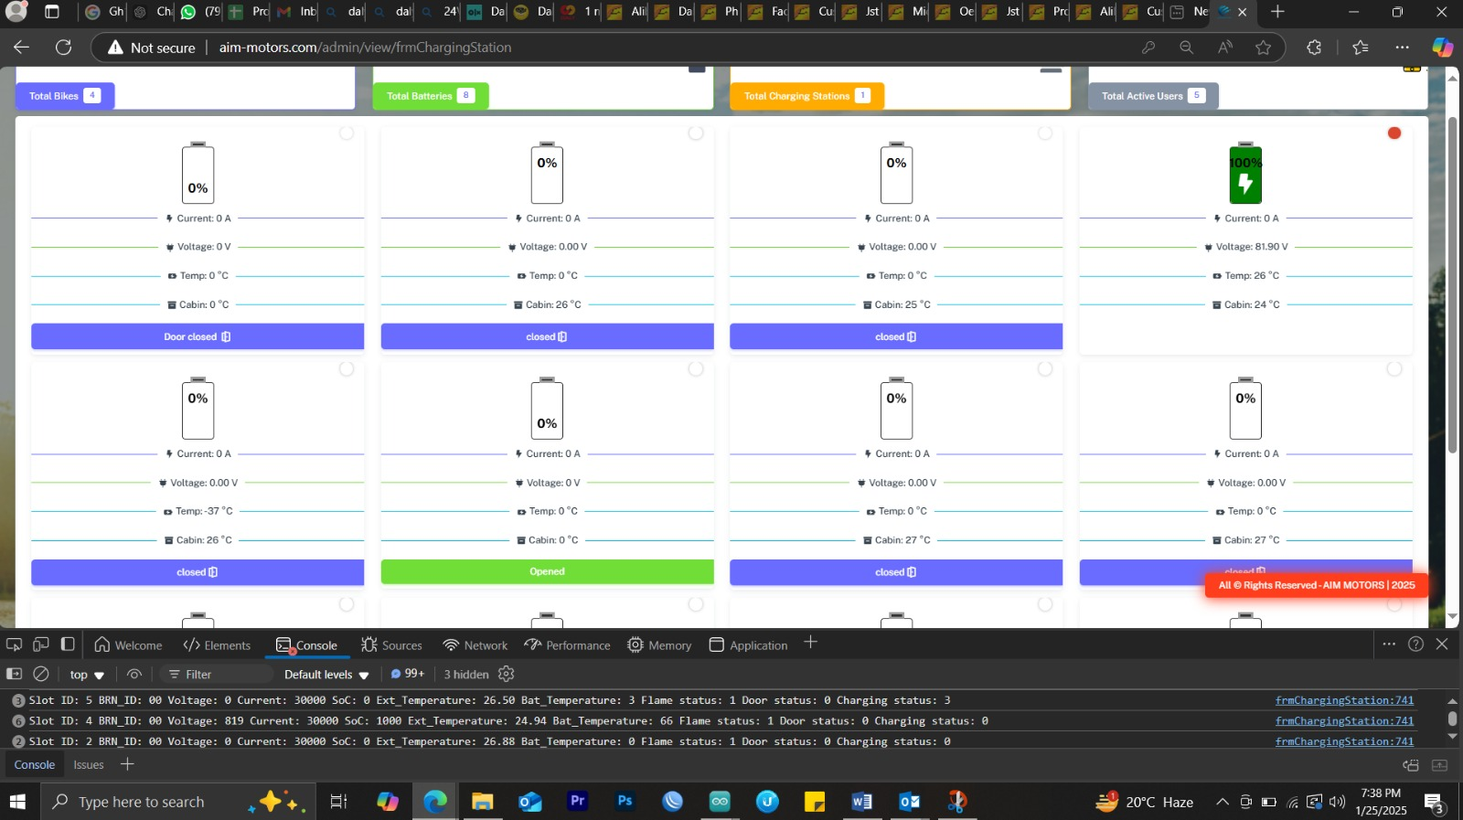
Slot 4 door is close but not showing on dashboard

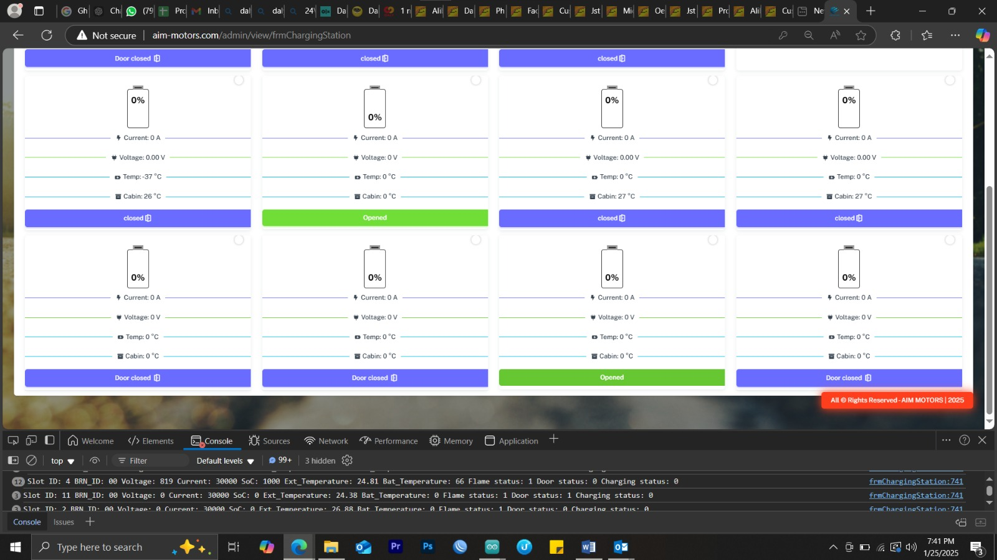
Slot 11 door status =1 but SOC data not showing

4. Assistance Availability
The electronics team is available to assist with any feedback or support required for addressing the identified issues, and are aslo prepared to work closely with the relevant teams to resolve server-side and hardware-related concerns promptly.

5. Load Testing Observations
During testing, the following AC load measurements were observed as batteries were sequentially plugged in:
- When 1 battery was plugged in, a load of 7.8A AC was observed.
- When the 2nd battery was plugged in, the load increased to 14.1A AC.
- When the 3rd battery was plugged in, the load increased to 17.8A AC.
- When the 4th battery was plugged in, the load increased to 23.4A AC.
Currently, only 4 batteries were available for testing. It is recommended to conduct full-load testing with all 12 batteries charging simultaneously to verify the system's performance under maximum load conditions.

Conclusion
The charging station is operational, with all 12 chargers functioning and charging batteries. Issues with Slot 6 and dashboard parameter displays have been identified as server-related and require further attention. The observation of one charger stopping after a spark has been noted, and corrective action will be taken. Upgraded circuit breaker infrastructure ensures enhanced safety and reliability. Full-load testing is recommended to validate the system's performance under maximum capacity.

